**REQUEST FOR GRANT APPLICATION (RGA)**

|  |  |
| --- | --- |
| **State Office:** | Utah Department of Health and Human Services |
| **Assistance Listing Title:**  **Award Number:**  **Assistance Listing Number:**  **Payment Method:**  **Funding Source:** | Working with Populations with Disproportionate Asthma Burden Grant  1 NUE1EH001525-01-00  93.070  Cost Reimbursement  Federal funding |
| **Total Award Amount:**  **Number of Awards:**  **Selection Method:** | $14,000 per year x 2 years  1-2 depending on available funding  Competitive |
| **Eligible Applicants:** | Tribal organizations, faith-based community organizations, or non-profit 501(c)(3) community-based organizations |
| **Due Date for Applications:** | October 9, 2024, 11:59 p.m. Mountain Time |
| **Funding Notification:** | Applicants will be notified of funding status on or before November 1, 2024 |
| **Project Period:** | The grant resulting from this RGA will be for the period December 1, 2024 - August 31, 2026 |
| **Grant Contact:** | Kellie Baxter, Health Program Specialist  Utah Department of Health and Human Services  Phone: 385-321-0434  Email: [kabaxter@utah.gov](mailto:kabaxter@utah.gov) |

**Table of Contents**

**Background3**

**Funding Opportunity Description6**

Applicant eligibility6

General purpose7

Populations to be served7

Review and award process7

**Application Instructions7**

Q & A7

Utah Department of Health and Human Services subrecipient terms8

Cost reimbursement9

Scope of work9

**Application Packet11**

Section 1: Cover sheet11

Section 2: Description of applicant12

Section 3: Populations to be served12

Section 4: Grant activities12

Section 5: Program structure & management13

Section 6: Budget14

**Appendix A: Grant Scoring Sheet15**

**Appendix B: Grant Requirements and Procedures16**

**Appendix C: Responsibilities of Grant Funding Recipients18**

**Appendix D: Grant Resources19**

**Appendix E: Grant Submission Checklist19**

**Background**

Asthma is an important public health issue in Utah. In 2022, about 11% of adults and 7% of children had current asthma, which is approximately 271,157 adults and 67,351 children in Utah (Behavioral Risk Factor Surveillance System).

**Figure 1.** Age-adjustedasthma emergency department rates by Local Health District, 2021-2022

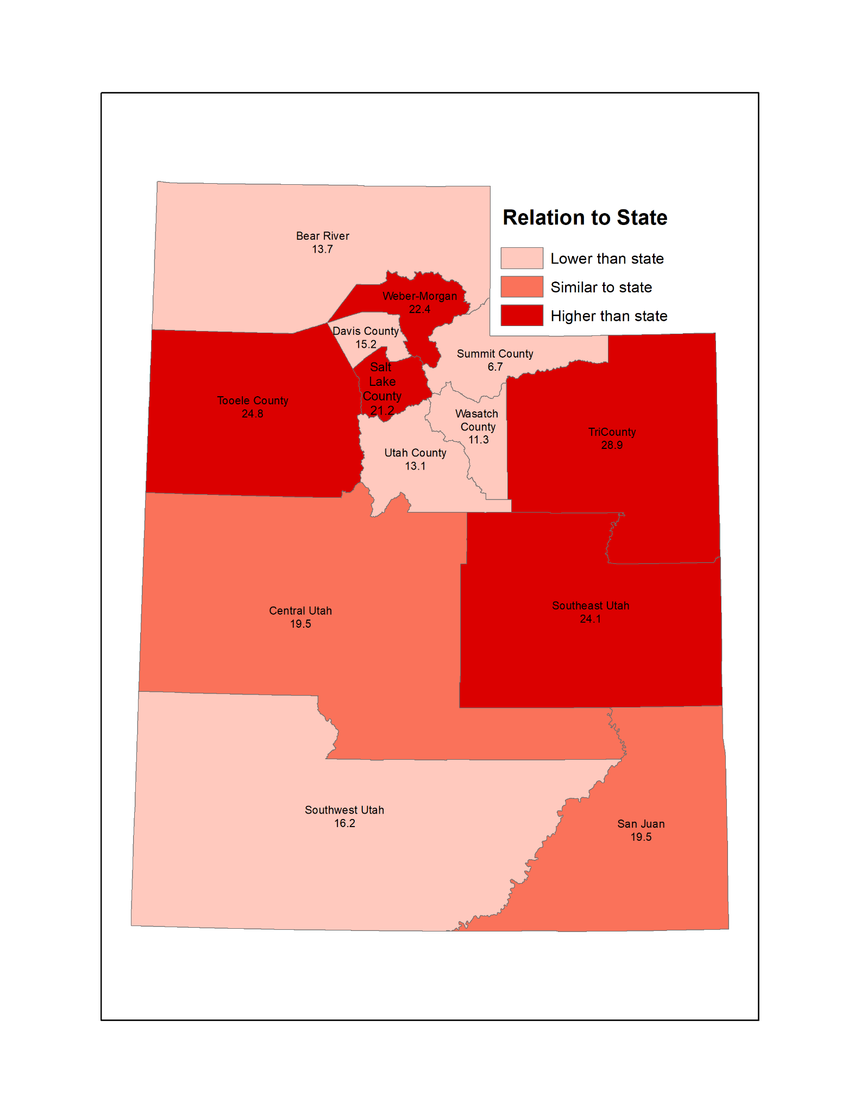

**Source**: Utah Emergency Department Encounter Database, 2021-2022. Note: The primary diagnosis code ICD J45 was used to identify ED visits due to asthma. Data include patients who were treated and released and those who were admitted as inpatients.

Weber-Morgan, Salt Lake County, Tooele County, TriCounty, and Southeast Utah Local Health Districts (LHDs) have asthma emergency department (ED) rates that are statistically higher than the state rate (22.4, 21.2, 24.8, 28.9, 24.1 vs. 19.2 visits per 10,000 visits) (Figure 1).

**Table 1.** Age-adjusted asthma emergency department visits by small areas, 2021-2022

|  |  |  |
| --- | --- | --- |
| County | Small area | Age-adjusted asthma ED rate per 10,000 |
| Box Elder | Tremonton | 24.2 |
| Weber | Ben Lomond | 24.0 |
| Ogden (Downtown) | 29.9 |
| South Ogden | 24.7 |
| Roy/Hooper | 25.5 |
| Riverdale | 29.2 |
| Weber/Davis | Clearfield Area/Hooper | 21.9 |
| Salt Lake | Salt Lake City (Rose Park) | 29.7 |
| Magna | 31.3 |
| SLC (Glendale) V2 | 34.9 |
| West Valley (Center) | 32.9 |
| West Valley (West) V2 | 25.9 |
| West Valley (East) V2 | 42.6 |
| Salt Lake City (Downtown) V2 | 41.5 |
| South Salt Lake | 40.8 |
| Kearns V2 | 30.8 |
| Taylorsville (East)/Murray (West) | 30.2 |
| Taylorsville (West) | 25.5 |
| Murray | 31.3 |
| Midvale | 32.4 |
| West Jordan (Northeast) V2 | 27.2 |
| Tooele | Tooele Valley | 29.5 |
| Daggett/Uintah | Daggett and Uintah County | 25.3 |
| Duchesne | Duchesne County | 39.9 |
| Carbon | Carbon County | 34.4 |
| San Juan | Blanding/Monticello | 32.1 |

**Source**: Utah Emergency Department Encounter Database, 2021-2022. Note: The primary diagnosis code ICD J45 was used to identify ED visits due to asthma. Data include patients who were treated and released and those who were admitted as inpatients.

Table 1 contains counties with small areas that have an asthma ED visit rate higher than the state rate of 19.2 per 10,000. LHDs that do not have higher rates may contain small areas with higher asthma ED rates than the state. For example, Blanding/Monticello has a higher asthma ED rate than the state (32.1 vs. 19.2 visits per 10,000 visits) but is located in an LHD with a similar rate to the state (19.5 vs. 19.2 visits per 10,000 visits).

**Graph 1**. Asthma prevalence by income, Utah adults (ages 18+), 2018-2022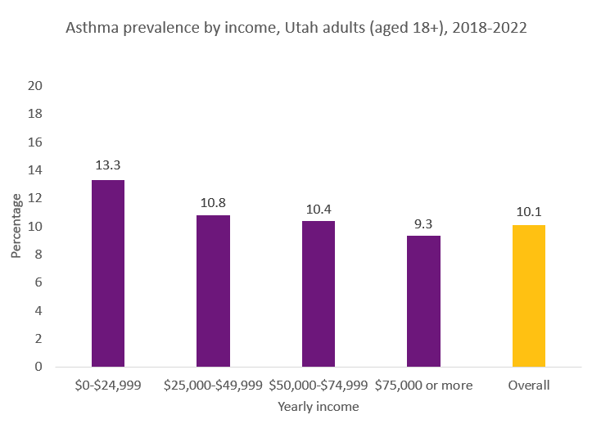

**Source**: Utah Behavioral Risk Factor Surveillance System, 2018-2022. Age-adjusted prevalence.

Those with lower incomes have a higher asthma prevalence than those with higher incomes. Those who make 0-$24,999 have a higher asthma prevalence than those who make $75,000 (13.3% vs. 9.3%). Additionally, when income groups are combined (not shown) those who make $0-49,999 have a higher asthma prevalence of 13.3% when compared to those who make $75,000+ at 9.3%.

**Graph 2**. Asthma prevalence by risk factor, Utah adults (ages 18+), 2021-2022

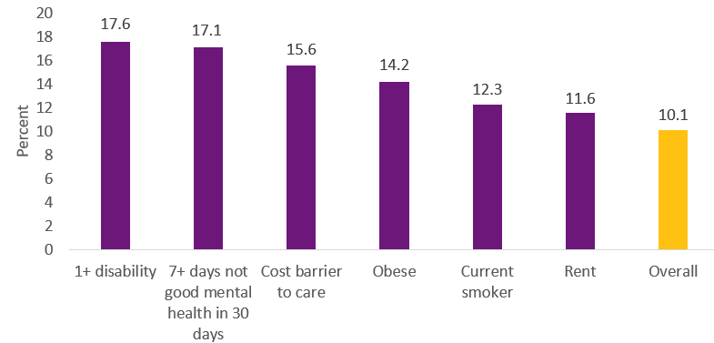

**Source**: Utah Behavioral Risk Factor Surveillance System, 2021-2022. Age-adjusted prevalence.

Adults with at least one disability and those with 7+ days of poor mental health in the past 30 days had a higher asthma prevalence than the overall estimate (17.6% and 17.1% vs. 10.1%). Those who report a cost as a barrier to health care or who rent their place of residence had a higher asthma prevalence than the overall estimate (15.6% and 11.6% vs. 10.1%). Those who report being obese have a higher asthma prevalence than the overall estimate (14.2% vs. 10.1%). Those who smoke cigarettes also had a higher asthma prevalence than the overall estimate (12.3% vs. 10.1%).

**Funding Opportunity Description**

The Utah Department of Health and Human Services (DHHS) is soliciting applications that will result in one or two grants.

**Applicant eligibility:** Organizations that meet the following criteria are eligible to apply for this grant.

1. Are a Utah-based tribal organization, faith-based community organization, or non-profit 501(c)(3) community-based organization serving communities in Utah;
2. Attest on page 11 that the organization (applicant agency) has resolved all State of Utah audit exceptions, resolution of judgments between the applicant and the State of Utah and fulfillment of all grant obligations by the applicant with the State of Utah;
3. Have the ability to engage a population based on the goals of this grant; and
4. Provide services in the scope of work and within the timeline outlined in this grant.

**General purpose:** The general purpose of the contract is to improve asthma outcomes among populations with disproportionate asthma burden, expand asthma services, and build linkages to services that address social determinants of health (SDOH).

**Populations to be served:**

Applicants must serve at least one population with disproportionate asthma burden. Populations with disproportionate asthma burden in Utah include:

* Those who reside in local health districts where asthma ED rates are higher than the state rate (Figure 1);
* Those who reside in small areas where asthma ED rates are higher than the state rate (Figure 2);
* Those with low incomes; and
* Those with a mental or physical disability.

**Review and award process:** Applications will be reviewed using the scoring sheet in Appendix A. No grant will be awarded if the application does not score a minimum of 60 points. Applicants will be notified of funding status on or before November 1, 2024.

# Application Instructions

Applicants must complete all sections in the Application Packet or the applicant will be disqualified from consideration. Submit the Application Packet in Microsoft Word or Adobe PDF file format.

Submit applications via email to Kellie Baxter [kabaxter@utah.gov](mailto:kabaxter@utah.gov) no later than Wednesday, October 9, 2024, at 11:59 p.m. All applications submitted after the deadline will be disqualified from consideration.

**Q & A:** All questions regarding this application can be directed to Kellie Baxter, [kabaxter@utah.gov](mailto:kabaxter@utah.gov). Answers to questions will be posted on the Utah Asthma Program website at <https://asthma.utah.gov/request-for-grant-applications>.

**Utah Department of Health and Human Services subrecipient terms:** All grants resulting from this RGA are subject to these terms. All applications submitted become the property of the State of Utah and shall not be returned to the applicant. The application may be reviewed by anyone designated by the State of Utah.

Additional conditions include:

Funding restrictions: These funds shall not be used for:

1. Research;
2. Clinical care;
3. Publicity or propaganda purposes, including preparing, distributing, or using any material designed to support or defeat the enactment of legislation before any legislative body;
4. Salary or expenses of any grant subcontrator, or agent acting for such subcontractors, related to any activity designed to influence the enactment of legislation, appropriations, regulation, administrative action, or Executive order proposed or pending before any legislative body;
5. Medical equipment that is planned to be distributed to individuals for individual care;
6. Personal health services, medications, medical devices (such as spacers, spirometers, or peak flow meters), or other costs associated with the medical management of asthma;
7. Scholarships for children to attend asthma camps;
8. Screenings to diagnose asthma;
9. Population-based asthma registry activities (such as a state-wide registry), unless associated with centralized use of electronic health records;
10. Furniture or equipment;
11. Construction, remodeling, or remediation projects;
12. Pillow cases, mattress covers, or cleaning supplies;
13. Fees for the Asthma Educator Certification exam;
14. Incentives or promotional items;
15. Payments to people to participate in programs, respond to requests for information or complete evaluation forms;
16. Support activities related to state tobacco control quit lines; and
17. Air monitors, moisture meters, sensors or other similar supplies.

**Federal funding:** The grantee shall comply with all federal funding requirements.

**Cost reimbursement:** This is a cost reimbursement grant, which reimburses the grantee for actual expenses incurred to provide services. No profit may be derived from this grant.

**Scope of work:** The Grantee will complete work in three areas.

1. Identify asthma-related health communication needs among the population the Grantee serves (i.e., what information does this population need to be able to better control their asthma?).

2. Provide the Utah Asthma Program with feedback on communication messages, program materials, and data collection tools to make sure they are appropriate for the population the Grantee serves. For example, this may include feedback on whether program materials are accessible and appropriate for the health literacy level of the population. Applicants will work with members of the population to review materials and provide feedback.

3. Identify individuals with asthma and provide referrals to asthma self-management education and community resources to address SDOH. Asthma self-management education will be provided through the Utah Asthma Home Visiting Program (UAHVP), which consists of three 60-90 minute in-home or virtual visits. The Grantee will work with Local Health Departments (LHDs) to refer eligible individuals to the UAHVP and help facilitate linkages to SDOH resources. In-home visits are currently offered through two LHDs, Salt Lake County Health Department and Utah County Health Department. Virtual visits are offered outside Salt Lake and Utah Counties.

Overview of expectations for referrals:

1. Identify individuals with asthma and screen them for the following (screening forms will be provided by the Utah Asthma Program):
   1. Barriers to asthma control
   2. Needs related to SDOH
   3. Eligibility for referral to the UAHVP
2. For those that are eligible for referrals to SDOH resources:
   1. Provide referrals to community resources to address SDOH. This may include, but is not limited to, sliding-scale medical clinics, health insurance navigation services, local housing programs for home remediation services, mental health services, substance abuse services, food pantries, sliding-scale dental care, education or job training services, transportation assistance, or other services to address physical and social needs.
   2. Attempt to follow up with at least 90% of these individuals one month after referral to see if they have been able to access the resources and provide additional support if needed.
3. For those that are eligible for referral to the UAHVP:
   1. Coordinate with the LHD to refer eligible individuals to the UAHVP.

Minimum requirements:

1. The Grantee will implement at least two strategies to identify asthma-related health communication needs among the population the Grantee serves. At least one of these strategies must be implemented in Year 1.
2. The Grantee will review UAHVP program materials and provide feedback on how the program can be improved to be more appropriate for the population served by the Grantee.
3. The Grantee will make sure at least six individuals with asthma per year enroll in the UAHVP.
4. The Grantee will refer individuals with asthma to community resources to address SDOH. 90% of these individuals will receive an attempt to follow-up via email or phone call one month after referral.
   1. Year 1: Refer at least 25 individuals with asthma to SDOH resources.
   2. Year 2: Refer at least 30 individuals with asthma to SDOH resources.

|  |  |
| --- | --- |
| **Application Packet**  Working with Populations with Disproportionate Asthma Burden Grant | |
| **Section 1: Cover sheet** | |
| Applicant agency name and mailing address:  Unique Entity ID (This is a 12-digit alphanumeric ID assigned by the federal government, see sam.gov for additional information):  State of Utah Vendor ID:  If the applicant is not a vendor with the State of Utah, submit the Division of Finance Vendor/Customer Creation Form and a Form W-9 (download at <https://finance.utah.gov/wp-content/uploads/FI170.pdf>) | |
| Contact name, telephone, and email**:** | Applicant legal status**:**  ☐ Tribal organization  ☐ Faith-based community organization  ☐ Non-profit 501(c)(3)  community-based organization  ☐ Other ________________________ |
| **Name and title of the applicant’s authorized signer:** | |
| *I attest that the applicant agency has resolved all State of Utah audit exceptions, resolution of judgments between the applicant and the State of Utah and fulfillment of all grant obligations by the applicant with the State of Utah.*  *I certify that all components of this application are true and accurate and agrees to all grant requirements and information provided in this document, and federal funding announcement.*  **Signature of authorized official: ________________________________________**  **Date:** Click or tap to enter a date. | |
| **Section 2: Description of applicant** | |
| Describe the agency applying for funding. Include experience and expertise serving the populations noted in this document. Provide at least one example of how your agency is a respected resource within the population(s) you plan to serve.(*500 words or less)* | |
| **Section 3: Populations to be served** | |
| Select which population(s) you intend to serve.  ☐ Those who reside in local health districts where asthma ED rates are higher than the state rate (Weber-Morgan, Salt Lake County, Tooele County, TriCounty, and Southeast Utah, see Figure 1)  ☐ Those who reside in small areas where asthma ED rates are higher than the state rate (see Figure 2)  ☐ Those with low incomes  ☐ Those with a mental or physical disability  Describe the population(s) your agency plans to serve through this grant (e.g. population characteristics, size of population served, where does the population live?) *(500 words or less)* | |
| **Section 4: Grant activities** | |
| How will you identify community members with asthma and get them to participate in asthma self-management education services and SDOH referral services? *(500 words or less)*  Describe existing communication channels you have to reach the population(s) you serve and the approximate reach of each channel (e.g. coalition meetings, events, social media, email list, etc.) *(500 words or less)*  What processes does your agency already have in place to  1) screen for needs related to SDOH, and  2) connect the population to community resources to address SDOH?  Please include details on any staff members already in place that help connect people to resources to address SDOH. If you do not have these processes in place, describe the process you plan to establish if funding is awarded. *(500 words or less)*  Describe your capacity to provide feedback regarding health communication messages, accessibility, and/or health literacy level appropriateness. Include at least one example of your past work in this area. *(500 words or less)*  Describe at least two strategies you will use to identify asthma-related health communication needs among the population you serve (i.e., what strategies will you use to identify what information this population needs to be able to better control their asthma?). *(500 words or less)*  How will you identify and involve community members in reviewing asthma-related program materials and health communication messages? *(500 words or less)* | |
| **Section 5: Program structure & management** | |
| Describe your agency’s fiscal and administrative ability to manage government funds. What strategies will you use to account for and manage funding?*(500 words or less)*  Describe the roles and responsibilities of staff members that will implement the activities outlined in this application. If applicable, describe how an employee already working at 100% will be capable of working on these grant activities. *(500 words or less)* | |

|  |  |  |
| --- | --- | --- |
| **Section 6: Budget**  Provide your estimated annual budget of $14,000. | | |
| **Year one budget period: December 1, 2024 – August 31, 2025** | | |
| **Category of Funding:** | **Justification:** | **Requested Funding Amount:** |
| Personnel Salary (include formula with hourly or annual rate) |  | **$** |
| Fringe Benefits  (include formula with hourly or annual rate) |  | **$** |
| Travel (in state only) |  | **$** |
| Supplies |  | **$** |
| Other (please describe) |  | **$** |
| Total amount requested |  | **$** |

**APPENDIX A:**

Grant Scoring Sheet

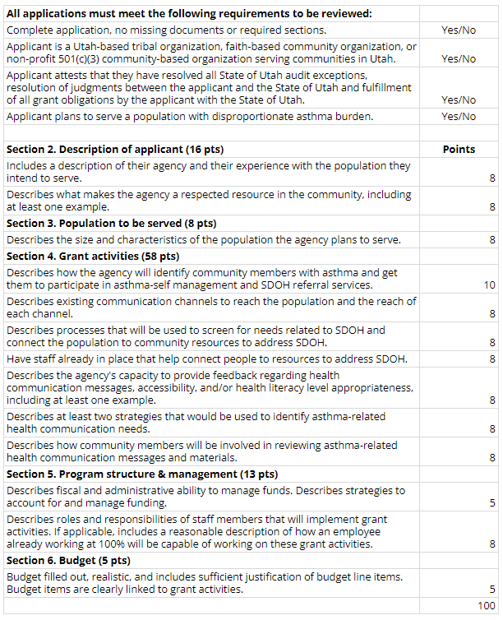

**Appendix B:**

Grant Requirements and Procedures

Best and Final Offer

The Issuing Agency may request a Best and Final Offer. This updated budget shall reflect the agencies best cost to deliver services. If the agency fails to respond to the Best and Final Offer request, the application shall not be considered for review.

A. Appeal of Award

All applicants will be notified of their award status. An applicant that claims to have been adversely affected by the selection of a competing agency shall have fourteen (14) calendar days after receiving status notification to submit a written appeal to Kellie Baxter (kabaxter@utah.gov). The Utah Asthma Program shall not consider an appeal submitted after the deadline.

B. Withdrawal

If an applicant wishes to withdraw a submitted proposal, it must be withdrawn prior to the proposal due date. A written request to withdraw must be signed by the applicant and submitted to the contact stated in this documentation before the due date.

C. Release of Information

No information shall be provided to the applicant (or any other individual) relative to their standing with other applicants, or the nature of their proposal, during the grant process.

D. Public Information & Confidential Information

The successful applicant’s proposal is public information after the award of the grant. If any part of a proposal is considered a trade secret, the applicant must clearly designate that portion as confidential in order to obtain protection from disclosure. Public Records Law shall determine if the confidential information claimed to be exempt is, in fact, exempt from disclosure.

E. Cost of Proposal Preparation

All costs incurred in preparing and submitting a proposal in response to this Grant is the responsibility of the applicant and will not be reimbursed by DHHS.

G. Grant Obligation

All applicants that submit a proposal in response to this grant understand and agree that DHHS is not obligated thereby to enter into an agreement with any applicant and has no financial obligation to any applicant.

H. Award Negotiation

DHHS may accept an applicant’s initial proposal by award of a grant with or without discussion to clarify proposals that are reasonably capable of receiving an award.

DHHS may also ask for best and final offers from bidders whose proposals are reasonably capable of receiving an award or negotiate with the apparently successful applicant. During any of these processes, the content of competing proposals will not be disclosed.

1. If discussions result in a need for material change to the grant or to proposals, DHHS will issue written requests for best and final offers, specifying the information to which each applicant is requested to respond. The request will specify the place, time, and date for receiving the written offers. If an applicant does not submit a notice of withdrawal or a timely best and final offer, the applicant’s proposal will be considered its best and final offer. If necessary, the State may issue a subsequent request for best and final offers. Best and final offers will then be re-evaluated.

2. DHHS may convene a negotiating team and negotiate with the apparently successful applicant if negotiation is in the best interest of the State. If a negotiated proposal is acceptable to both parties, a grant may be awarded. If the parties are unable to agree, the State may terminate the negotiations in writing and negotiate with the next ranked applicant.

**Appendix C:**

Responsibilities of Grant Funding Recipients

A. Reports

1. Quarterly invoices

The Grantee will be required to submit quarterly itemized invoices by the 10th of the month following the end of each quarter. All billings and fees are subject to approval and audit by the State.

2. Quarterly progress reports

The Grantee will submit quarterly progress reports by the 10th of the month following the end of each quarter. Progress reports should describe efforts to complete activities outlined in the scope of work.

B. Training Requirements

The Grantee will be required to attend one training provided by the Utah Asthma Program. The training will be held at the beginning of contract period.

C. Meeting Requirements

Grantees will be required to participate in meetings with the Utah Asthma Program and LHDs via conference call. A meeting schedule will be agreed upon by the Grantee and Utah Asthma Program.

D. Site Visit

Grantees will be required to participate in one site visit during the contract period. Site visits provide an opportunity for the Utah Asthma Program to review grant requirements, provide progress report feedback, participate in Grantee meetings, or attend community events.

E. Grantee Requirements

The projected start date for the contract is December 1, 2024. The grant period is December 1, 2024 to August 31, 2026. Contract continuation depends upon satisfactory performance and availability of funding from CDC. DHHS has the authority to terminate the contract at any time during the contractual period.

**Appendix D:**

Grant Resources

Asthma Resources

* Utah Asthma Program website <https://asthma.utah.gov/>
* Utah Asthma Program Strategic Plan <https://asthma.utah.gov/wp-content/uploads/stateplan2020-1.pdf>
* CDC’s National Asthma Control Program EXHALE Strategies <https://www.cdc.gov/national-asthma-control-program/php/exhale/index.html>
* Utah Asthma Data <https://ibis.utah.gov/ibisph-view/topic/Asthma.html>

Social Determinants of Health Resources

* CDC’s Social Determinants of Health website <https://www.cdc.gov/about/priorities/why-is-addressing-sdoh-important.html>
* Healthy People 2030 <https://health.gov/healthypeople/priority-areas/social-determinants-health>
* Addressing Social Determinants of Health and Chronic Diseases <https://www.cdc.gov/health-equity-chronic-disease/social-determinants-of-health-and-chronic-disease/index.html>
* Utah Healthy Places Index <https://dhhs.utah.gov/UtahHPI/>

**APPENDIX E:**

Grant Submission Checklist

Excluding any of these required documents will disqualify the application for review.

* Application packet, see pages 11-14
* Unique Entity ID
* IRS 501(c)(3) tax-exempt designation letter (if applicable)
* State of Utah Vendor ID
  + If the applicant is not a vendor with the State of Utah, submit the Division of Finance Vendor/Customer Creation Form and a Form W-9 (download at <https://finance.utah.gov/wp-content/uploads/FI170.pdf>)